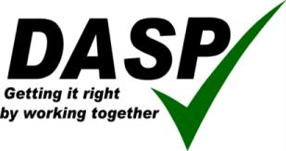

Annual Review for the Year ended
31 August 2014

Company Number: 07621347

Contents Page

Introductory Note 3

Objectives and Activities 4 - 5

Achievement and Performance 6 - 8

DASP Improvement Plan 9

Review of last year 10 - 18

Standard Contribution 19

DMIS Contribution 19

Appendix – Financial Report

INTRODUCTORY NOTE

DASP Limited is a company limited by guarantee registered on 4 May 2011 at Companies House under number 07621347. The members of the company are the governing bodies of each of the participating academies and schools represented by their respective chairs. Until 31 August 2014 the company’s directors were the heads of the participating academies and schools.

On 16 June 2011 the members entered into a formal Members’ Agreement to regulate the way in which the company was to operate.

Clause 11 of the Members’ Agreement requires the directors to submit an annual review consisting of a report of the activities of the Company during the then current financial year with outcomes clearly set against original planed targets, an assessment of the work of the company during the next financial year and of any particular matters which in the opinion of the Board may pose particular problems or difficulties, a budget for the next financial year, a strategic plan for the next three financial years and any proposals which the Board may have for altering the amount of the Standard Contribution or the percentage of the DMIS Contribution.

The review which follows is the Annual Review referred to above for the year ended 31 August 2014.

In April 2014 the members agreed to certain changes to the way in which the company is run and these will be formalised at a specially convened meeting on 22 January 2015. The main change is to streamline the executive board by reducing the number of directors and to establish a consultative group consisting of all heads of participating academies and schools.

OBJECTIVES AND ACTIVITIES
Objects, aims and activities
The object of the company as stated in its articles of association is to provide resources and support of an educational nature for the Members.
Learning is Everything
Our Purpose
Our purpose is to unlock the potential in every young person by providing outstanding opportunities for learning.
Our beliefs
1 We believe in the power of learning as a means to transform lives
2 We believe that every young person has a talent that can be nurtured through relentless optimism
3 We believe that mutual respect is the foundation for good relationships and that we should act with care, concern and generosity towards each other
4 We believe learning for life is best provided in an environment where young people come together regardless of ability, background or religion

Our strategic direction
1 To promote equality, continuity of experience and ease of transition 3-19 (one learning community)
We will:
- Continue to work in close partnership at key points of transition in mini-pyramids and within the KS3 community of schools
- Use newly re-constituted headteacher meetings to address issues around continuity and consistency
- Develop a new system of tracking and assessment (3-19) as a key priority in the 2014-15 Improvement Plan
- Commission an annual data trawl to ensure that issues around consistency, continuity and equality of opportunity are addressed openly and supportively
- Continue to investigate more formal partnership working through federation and multi-academy trusts as we move towards the vision of one learning community

2 To ensure continuous improvement in learning – to continuously raise standards
We will:
- Use the Raising Attainment Plans to address improvement issues in localities
- Target disadvantaged children as a key priority for progress and in particular to raise levels of attendance
- Implement a programme for reading recovery at KS1 across all first schools
- Increase the number of children reading for pleasure across all year groups
- Develop the use of literacy in lessons across all year groups
- Set up two action groups for the improvement of standards in literacy and numeracy

3 To provide school to school support – to each other and to others
We will:
- Audit existing provision for music (under the leadership of the new DASP Music Coordinator) and aim to increase the take-up of lessons and participation
- Re-consider the strategy to increase participation in sport under the Olympic Legacy funding stream
- Use headteacher meetings to consider how best schools can support each other as part of the DASP community of schools
- Review the use of services for special educational needs to ensure best value

Safeguarding
DASP schools are committed to safeguarding and promoting the welfare of our
students and expects all staff and volunteers to share this commitment.

Equal Opportunities
The directors recognise that equal opportunities should be an integral part of good practice within the workplace. DASP schools aim to establish equal opportunity in all areas of its activities including creating a working environment in which the contribution and needs of all people are fully valued.

ACHIEVEMENTS AND PERFORMANCE
Key achievements 2013/14
- DASP mission, purpose, beliefs and strategic direction established
- Re-structuring and re-organisation of staffing completed according to plan
- New model of leadership and governance successfully implemented
- Balanced budget achieved and future predicted deficits wiped out
- Sustained and improved examination performance at GCSE and A Level
- DASP Improvement Plan in place with defined priorities
Performance at GCSE Level
 |  | School % |  |  | Dorset LA % |  |  |  | National %
 |  | 2012 | 2013 | 2014* | 2012 | 2013 |  | 2014* | 2012 | 2013 | 2014*
5+ A-C inc En/Ma | All | 65 | 68 | 68 | 54 | 59 |  | 61 | 59 | 60 | 53
 | Disadvantaged/  Advantaged Gap | 36 | 34 | 22 | 30 | 27 |  | 26 | 26 | 27 | n/a
C+ GCSE | English | 78 | 78 | 77 | 64 |  | 69 | 69 | 68 | 70 | n/a
 | Maths | 70 | 75 | 75 | 65 |  | 70 | 72 | 68 | 70 | n/a
KS 2-4 Progress  English | 3 levels | 84 | 81 | 82 | 63 | 68 |  | 75 | 67 | 69 | n/a
 | 4 levels | 49 | 50 | 49 | 25 | 29 |  | 36 | 28 | 30 | n/a
 | Disadvantaged/  Advantaged Gap | 22 | 19 | 12 | 23 | 22 |  | 14 | 19 | 19 | n/a
KS 2-4 Progress  Maths | 3 levels | 76 | 78 | 76 | 64 | 69 |  | 69 | 68 | 70 | n/a
 | 4 levels | 46 | 49 | 43 | 28 | 30 |  | 30 | 31 | 32 | n/a
 | Disadvantaged/  Advantaged Gap | 25 | 37 | 14 | 27 | 28 |  | 19 | 22 | 23 | n/a

*unvalidated
On entry to year 9 student attainment is average (27.3 average point score) compared to other Dorset schools (27.3) and marginally above the national average. However, by the end of Key Stage 4 students are performing significantly beyond expectation. Despite the swingeing changes to the exam system and to performance measures, students have maintained excellent progress. It is particularly pleasing to record such high performance in literacy and numeracy and to have narrowed the gap between advantaged and disadvantaged students – a key priority in the school improvement plan for 2013-14.

Post-16
 | 2012 | 2013 | 2014
PPC | 860 | 639 | 743
PPE | 231.5 | 228 | 229
A*-E | 98.5% | 98.4% | 97%
A*-C | 83.9% | 79% | 83%
A*-B | 63.3% | 55% | 65%
A*-A | 34.1% | 25.3% | 32%
IB | 31.6 | 33.2 | 32

The 2014 A level results (A2) were outstanding. Based upon the prior attainment of the students, these outcomes place Thomas Hardye in the top 7% of schools nationally and the highest performing post-16 provider in Dorset. Retention rates remain very high suggesting that the pastoral support for students is also outstanding. The vast majority of students go on to higher education with most gaining a place at a Russell Group university. This is very satisfying and reflects the high aspirations we have for all students.
KEY STAGE 4

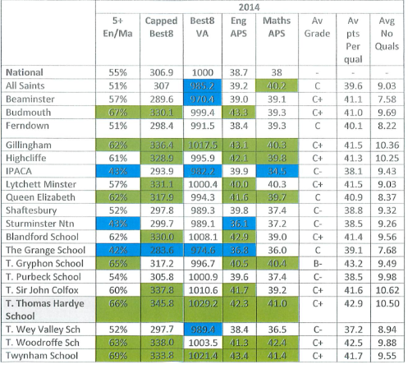

KEY STAGE 2

YEAR 4
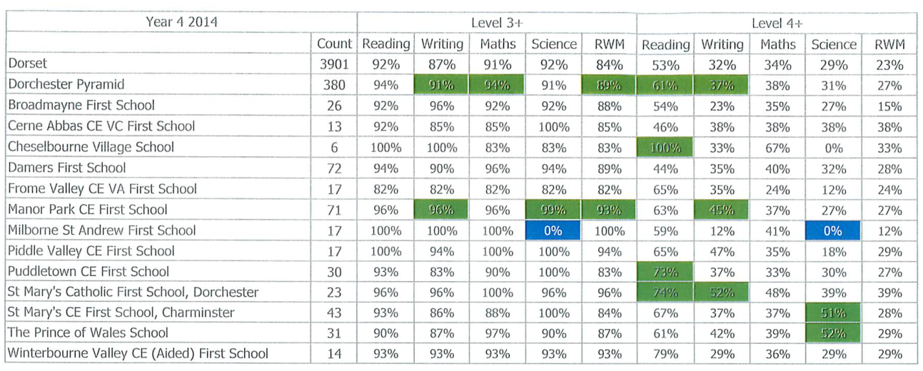

KEY STAGE 1

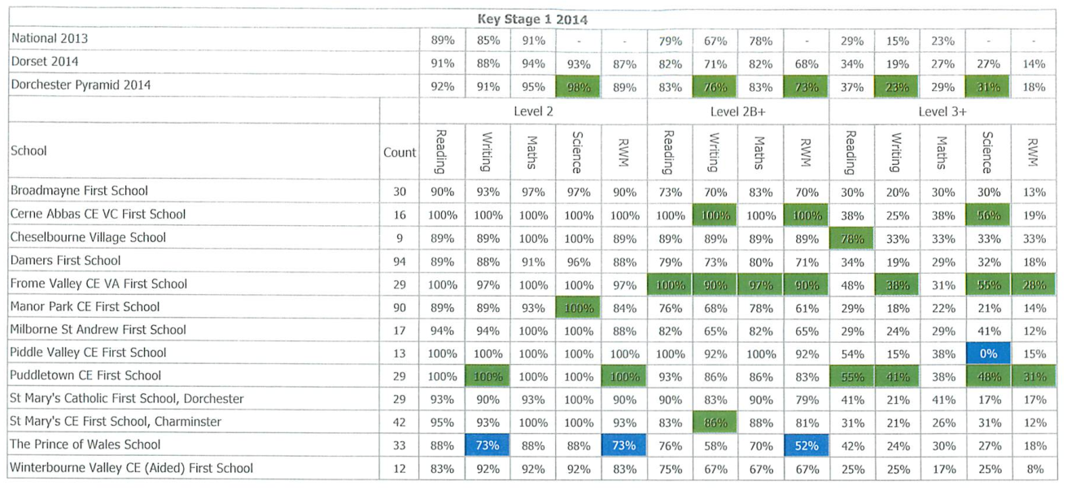

DASP IMPROVEMENT PLAN 2014-17

Principal risks and uncertainties that may prevent us from achieving our objectives
- DASP’s capacity to initiate change has improved significantly following the appointment of Karen Weir as DASP administrator. However, if DASP is to develop its own services or procure its own services, capacity will need to be increased further, particularly in the area of finance and resources.
- Education funding is likely to come under further pressure in the new parliament. Re-organisation of DASP means that there is no immediate need to raise subscriptions and there may even be an argument for reducing them but financial sustainability is not secure. Small schools and schools with specialist bases are particularly vulnerable.
- Closer federation or trust arrangements will necessitate changes in traditional forms of leadership and governance and potential loss of autonomy. This will need a careful process of change management to make sure that stakeholders do not feel disenfranchised or excluded.
- The emphasis on improving standards requires all schools to share data and explore strengths and weaknesses openly as part of on-going school to school support.
- The three tier system is under threat which will eventually have an impact on staffing in our middle schools. The three tier system is likely to come under increasing scrutiny unless we improve outcome at Key Stage 2 and show progress.
- The recruitment of teaching staff remains a challenge and the age profile of teaching staff suggests that there will be a need for an effective programme of succession planning over the next 10 years. The recruitment and retention of headteachers is likely to be a particular problem.

How did we fulfil our strategic objectives in 2013/14?
Objective 1 – To promote equality, continuity of experience and ease of transition 3-19
The Partnership’s Strategic Plan for 2013/14 academic year focus was raising attainment through the development of one learning community through the adoption of what has been termed a ‘one school’ approach. The underlying principle is that any child within the Partnership should have equality and continuity of experience from 3 -19, irrespective of the individual schools they attend. The following examples below show how we have endeavoured to turn this philosophy into a reality this year.
- Within the Partnership we have developed an organisational structure based on three ‘mini-pyramids’ – these pyramids consist of a middle school and its feeder first schools. Regular meetings take place between the pyramid Headteachers, which focus on raising attainment; each pyramid has developed its own Raising Attainment Plan (RAP) which focus both on the DASP priorities and any local needs. Priorities this year have included improving outcomes at Key Stage 2 in Reading, Writing and Mathematics by establishing greater accountability between the partner schools; improving the quality of teaching and learning through the dissemination of best practice, and developing a shared approach to assessment and the monitoring of progress, including the purchase of the ‘Pupil Tracker’ software package. Another common strategy that we have developed at pyramid level is joint work scrutiny and moderation between schools. The aim of this work is to develop a confidence in the data received at transfer.
- Within our meeting structure we have provided sufficient time for the headteachers of the 14 first schools to meet regularly. The main aim of these meetings is to provide an opportunity for leaders to share initiatives and strategies and to progress any actions on the Strategic Plan with the aim of developing equality of experience. Formal minutes of these meetings are produced and circulated to all directors. A key priority of this group has been improving literacy, particularly Reading through phonics and Reading Recovery programmes.
- In order to support the transition from first to middle school, we have employed Transition Mentors in two of the pyramids who work alongside vulnerable Year 4 children during the spring and summer terms preparing them for transfer. The Mentors then support the identified children during the autumn term of Year 5. This strategy also includes outreach work with parents and carers. In the St. Mary’s middle pyramid a similar model is being adopted through the use of suitably trained Emotional Literacy Assistants (ELSA).
- At Key Stage 3 the headteachers of the middle and upper school also meet regularly to ensure a consistency of experience in terms of curriculum and transfer arrangements. Again, formal minutes of these meetings are circulated to all directors for information. After evaluating our work as a group, we have decided to produce a Raising Attainment plan for Key Stage 3, which will supplement the DASP Development Plan and the RAPs implemented at ‘mini-pyramid’ level.
Objective 2 – To ensure continuous improvement in learning, thereby raising standards year on year
The core purpose of our partnership is to provide a high quality education for all the young people in the Dorchester area with the aim of improving their life chances. Whilst there are many strengths, we realise that through effective collaboration we can further raise standards, especially at the end of Key Stage 2 and for children entitled to Pupil Premium funding.
Literacy
In 2013 we held a two day conference to review our work and to consider our future priorities. The 2013/14 Development Plan was produced as a result of these discussions and it was agreed that the on-going priority across all phases would be improving literacy skill with a focus on Reading for both understanding and pleasure.
- We established the Literacy Steering Group to lead the initiative at partnership level. This group was made up of headteachers and key literacy leaders from a number of schools. An update of the work of this group was provided at all meetings of the directors so impact and progress could be monitored.
- We employed the services of Jane Davies, a Literacy Consultant and registered Ofsted inspector, to work with the Literacy Steering Group to review current strategies within our schools and to develop a Literacy Strategy 5 -19. An external audit of literacy provision in four DASP schools was undertaken by Jane Davies and her subsequent report helped to inform our strategic plan.
- The main objective of the Literacy Strategy was to ensure that all children across the partnership do not fall below 2 years of their chronological age in reading (measured by standardised reading tests). We are developing a Reading Recovery programme to provide timely intervention for any child who does not meet the above criteria. This has included training for teaching assistants in Reading Recovery and phonics work and the production of DASP Reading Tips for Teachers, which was published and circulated to all teaching staff in January 2014.
- Another key aim of the strategy is to develop and embed a culture of reading for pleasure within our schools. It is our aim to develop a love of reading and a joy of literature. In February the DASP Book Group initiative was launched at Dorchester Library for Year 4 and Year 7 pupils, who received training and guidance on how to establish a Book group within their own school. Age appropriate book reviews have been produced, which are accessible via the DASP website.
- In March 2014 a Pupil Literacy Survey was produced and added to the DASP website and a parental guide to reading strategies and an instructional video are also available to support parents in developing reading at home.
- In October 2013 a joint training day for all schools was organised. The theme of the day was developing effective literacy across all subjects, and the event was led by Phil Beadle, literacy trainer and a former recipient of a National Teaching Award. A separate session was convened on the same day for support staff, led by Jane Davies. The purpose of the training was to provide a catalyst for literacy improvements within the individual schools.

St Osmund’s Mini-pyramid Raising Attainment Plan
Impact Report
2013-2014
 | Success Criteria | Actions | Outcomes | Impact
Connected Curriculum | An understanding of Literacy coverage across all curriculum areas  Literacy is being taught across all subjects | Middle School to find out about First School curriculum.  To look at the New National Curriculum and consider the content of topics to ensure there is consistency and development across First and Middle School.  Staff sharing knowledge and understanding of Literacy in the new National Curriculum, leading to a review of the strengths, areas for development.  External facilitation through:  - Work Scrutiny  - Lesson Observation  - Moderation  The above methods will be used to look at Literacy but through other subjects.  A topic transition project. | St Osmund’s have a good understanding of how First Schools are teaching the curriculum.  Work scrutiny had been positive with good Yr 5 feedback. Moderation had gone well and staff felt more was needed next year and that it needed to be more rigorous. Year 5/6 teachers will look to see how work with First School teachers could be improved, involving more years. Agreed that moderation should involve teachers from Yrs 2 – 6 and this would happen from September. Lyn Gaudreau to be invited to participate. Suggested that we look at work from an existing level rather than from a year group.  Sharing knowledge and understanding of new curriculum – meeting was good. Group keen to meet again.  Transition project not so successful as children wanted to start anew when joining new school.  Consideration of topics taught in Humanities – meeting held. | The greater understanding that the Middle School Staff have about literacy across the curriculum has meant that there has been a link between the teaching of Humanities and Literacy. Literacy key objectives have been used within the teaching of Humanities giving pupils a greater opportunity to develop their writing and comprehension skills.  Moving into Year 6 this cohort has now been able to utilise their literacy skills within a number of subject areas.  Within whole staff meetings there has been a Literacy focus e.g. sharing of spelling policy.  There is now a raised importance in the marking policy in reference to grammar and spelling for all subjects.
Reading | ALL children to be reading within 2 years of their chronological age | Agree on the same reading test then test children at end of each year and mid year.  Using this info set up a grid showing key children for monitoring.  Regular discrete phonics for reading and/or writing to be taught to all Year Groups up to Year 6 as needed. Staff continue with phonics training and observations across the pyramid.  Guided Reading training and observation for Middle School Staff.  Set up a network meeting for staff trained on Wave 3 FFT to support each other. | New test (NGRT) introduced.  Reading below chronological age by 2 years - look at results in autumn when grids analysed.  Not many children in First Schools 2 years and below in reading. Need to look at children between 1 and 2 years next year.  Regular and discrete phonics up to Yr 6 – this is a developing area but more work still needed with Yrs 5 and 6. DASP skills sessions were good and there has been an increase in children being daily readers. Project for parents e.g. a blog, book club, leaflet had all been done by DASP. | There were 9 children in Yr. 3, 5 children in Yr. 4 , 15 children in Yr. 5 and 8 children in Yr.6 reading 2 years below their chronological age. These children either have a statement of SEN or are receiving additional support for their reading.  Next year we will be able to see if the outcomes have had an affect on reducing the number of children reading 2 years below their chronological age.
Joint accountability | Heads have a knowledge of key children in the mini-pyramid | To set up a grid that could be used during any meetings that will share information about ‘natural at risk’ key children. 1 for Maths, 1 for reading, 1 for writing.  First Schools to share Year 2 cohort data on an annual basis. | Joint accountability grid looking at 2C and 3C children had been updated each term, will be more useful as time progresses. Helen Pegram to receive end of year copy and to look at children who had not made required progress.  Schools to share Yr 2 and Yr 6 data to inform mini-pyramid on possible successes and areas of concern.  Knowledge of key children is continually shared. | St Osmund’s Mini-pyramid had a change of Head in the middle of the school year. Heads discuss this vulnerable group of pupils on a termly basis at least. The appropriate interventions are shared in order to maximise progress through transition.  There is a greater shared accountability for the outcomes at the end of KS2.
Maths | 90% of cohort achieve 2 levels progress | To identify ‘natural at risk’ children i.e. L2C and L3 at end of KS1 for Maths for monitoring.  Review DASP written calculation strategies in light of NC.  Intervention strategies discussed across pyramid and observations held of maths interventions | Maths – 2 levels progress for 2C and 3C children is a 4 year target.  DASP maths will look at Calculation Strategies next year.  Intervention strategies in maths– meeting very successful. Next step identified is to look at how different interventions work in schools, each school to look at an intervention they are not currently using. | As this is a 4 year target we are unable to share whether the Success Criteria has been met yet. However Key children are now being closely monitored to ensure they get the necessary support if required during any year group in KS2.

Dorchester Middle Pyramid Raising Attainment Plan Impact Report 2013-14
The key objective of the RAP was to improve writing with a focus on Years 2 to 6. Of the main strategies adopted, the one which had the greatest impact was the creation of a cross-phase three tier writing moderation programme. This programme enabled schools to moderate writing judgements at whole-school level before collaborating termly with colleagues from other schools to agree judgements. The process was then externally validated by an LA Literacy Consultant. These meetings were well attended by all schools and allowed an opportunity to explore moderation of judgements alongside developing subject knowledge and skills in the light of the new curriculum. They allowed staff an incredibly valuable insight into the marking and feedback techniques used by colleagues and an opportunity to share good practice and learn from each other. The primary model now established in the middle school has ensured a common ground within these meetings for colleagues to explore the application of writing skills across the curriculum and the sharing of effective target setting practice. Headteachers felt that the writing moderation programme played a significant role in both confirming and challenging our own internal moderation and assessment systems and increasing staff understanding of what constitutes outstanding practice.
Outcomes for Year 6 pupils have improved consistently over the last 2 years. Since 2012 pupils achieving Level 4 at writing at KS2 have increased by 21% and Level 5 by 13%. This year saw a 5% increase in pupils achieving Level 4+ in writing and a 1% increase in pupils achieving Level 5+. The Spelling, Punctuation and Grammar (SPAG) test has also seen an increase of 8% Level 4+ and 7% Level 5+.
As a result of regular professional interaction and dialogue there is now a more firm foundation for a greater shared accountability for outcomes at the end of KS2 and we intend to develop this further this year. As a result of the impact of the writing moderation programme, termly cross phase writing moderation meetings are now an established part of the mini-pyramid planning cycle. To reflect the impact and value that this level of professional interaction has had on outcomes for children, we are now using mini-pyramid funding to hold these meetings during the school day, rather than as twilights. We have also now established a similar three tier model to facilitate cross-phase maths moderation.

St. Mary’s Mini-pyramid Raising Attainment Plan Impact Report 2013 -2014
The pyramid identified the following key priorities for 2013 - 14:
- Raising achievement in Mathematics, particularly improving progress from Key Stage 1 to Key Stage 2.
- Improving the quality of teaching across the pyramid and, therefore, improving outcomes for children.
- Investigating models of leadership and governance to raise standards through consistency of practice and greater accountability.
The implementation of the plan was co-ordinated by the Headteachers, who met regularly, with responsibility for specific actions delegated to key staff.
- Raising Attainment Plan: Mathematics
The key objective of the plan was to allow all pupils to make 14 points progress from the end of Year 2 to the Year 6. The success criteria agreed to measure performance was the overall percentage of children in the mini-pyramid making 2 levels of progress would be above the Dorset average. In order to achieve this aim the following actions were taken:
- Aspirational targets were set, which were based upon 14 points progress for all children in Years 3 & 4 These were cross referenced with FFT-D predictions.
- Agreed strategies for the four main mathematical operations were discussed and agreed, which provided a core common progression in calculation methods. This included a joint twilight training session for all teachers in the pyramid.
- A transition project with a focus on improving problem solving skills was developed and introduced. This included a visit to each first school by the middle school Maths Leader and the use of exercise books throughout the summer term, which were passed on to Year 5 staff.
- An audit of medium term plans in each school to ensure a consistent coverage of the mathematics curriculum.
- The moderation of maths’ work throughout the pyramid to agree levels.
Evaluation of impact
In 2014 the pyramid achieved its best ever Maths results at Key stage 2 (attainment at Level 4+). Analysis has shown that 86% of children made the expected progress and the attainment gap between children eligible for Pupil Premium and other children was closed (in fact, the achievement of pupil Premium children was higher than the cohort, as a whole). Overall, pupils made 12 points progress from Key Stage 1 to the end of Year 6; therefore, the aspirational target of 14 points was not met. Predictions suggest that the 2015 results should be in line with or better than those achieved this year. Mathematics remains a pyramid priority and a revised RAP has been produced, which is in line with the DASP Numeracy Plan.
- Improving the quality of teaching.
After a launch conference, led by the educationalist Mike Hughes, the pyramid decided to focus on improving the quality of teaching to improve pupil outcomes. The aim of the plan was to develop a culture within and across the schools to develop new and innovative approaches to teaching and learning and then to disseminate ‘best practice’. The following actions were taken:
- ‘Phase Teams’ were established -Reception and Year 1; Years 2 and 3; Years 4, 5, and 6; and Years 7 and 8. Each team was tasked with developing an area of action research that would lead to improved learning in the classroom.
- Each team was responsible for producing an action plan, sharing findings, refining and developing classroom practice and gathering evidence of impact.
Evaluation of impact
Although initial meetings of ‘Phase Teams’ took place and actions were agreed, the teams failed to meet on a regular basis and, therefore, momentum was lost. Whilst best practice was developed and shared in individual schools, this was not shared at pyramid level, as the proposed joint INSET day did not take place. School Leaders have assessed the quality of teaching as good within each school and good overall for the pyramid; however, further work is needed to develop more consistent outstanding practice; this remain a priority for 2015 and 2016.
- Establishing greater accountability and consistency of practice through formal collaborative working.
Whilst the schools within the pyramid have established a close working relationship through DASP and at a local level, it was agreed to investigate the establishment a more formal collaboration between schools, with the aim of improving outcomes for children through shared accountability.
The following options were considered:
- Soft federation of schools with a degree of shared governance.
- The formation of a co-operative trust
- The establishment of a Multi- Academy Trust (MAT)
After much discussion, it was decided to formally investigate establishing a MAT, which would include all the schools in the pyramid. A consultant to advise and guide Headteachers and Governors was procured through the Diocese of Salisbury and various meetings were convened, which involved Governors from each pyramid school.
Evaluation of impact
In June 2014 St. Mary’s Middle, Broadmayne, Frome Valley, Milborne St. Andrew, Piddle Valley, and Puddletown First Schools agreed in principle to form a Multi-Academy Trust with a proposed conversion date of April 2015. Each of the named first schools received Academy Orders in August 2014 and a Steering Group of Headteachers and Governors was established to lead the process.
Objective 3 - To provide school to school support to each other, and to other partners.
The development of services internally was another key objective of the partnership’s Development Plan; our aim is to provide effective and efficient services to all DASP schools, incorporating the principles of ‘best value’.
The Dorchester Maintenance and Indemnity scheme (DMIS): This scheme provides financial support for small scale capital projects (£1500 - £15000). It has been in existence for a number of years and is managed by a Steering Group, which includes a Property Surveyor from Dorset County Council, who is responsible for surveying the member schools and prioritising a works programme. This year we managed to overcome issues surrounding VAT, which resulted from four schools converting to Academies, and establish a revised programme of works based upon priority needs. The use of pooled funding enables work to be undertaken that would be unaffordable to individual schools; this is particularly beneficial for the smaller schools within DASP.
DASP Music Service: The DASP Music Service coordinates instrumental tuition across the partnership, provides a range of music groups and ensembles, and organises joint concerts, enabling the children to have the opportunity to perform in front of a large audience. Through pooled funding we are able to finance a small team of administrative staff to support the team of peripatetics and deal with parents. This year a Development plan was produced and implemented by James Baker, DASP Music Coordinator until September 2014. We have invested in a new music software package to create efficiencies within the administration; this has already resulted in a substantial saving in time and the cost of printing and postage.
The Olympic Legacy Project: This project was established in September 2013 and is financed through the Primary Sports Grant. Each middle and first school has used 50% of the funding available for Primary aged children to employ three Olympic legacy Leaders (OLLs) through the Partnership. Each Leader works with one pyramid of schools and is responsible for implementing a programme of inter-school competitions and specialist coaching. The Sports Leader Programme, which has been developed across the three middle schools, has provided an opportunity for Key Stage 3 pupils to develop their own leadership potential through working with younger children in the feeder schools. We are currently reviewing and evaluating the project; however, there is no doubt that the work of the Leaders has raised the profile of sport across the partnership.

Please see attached appendices for the Financial Report and Accounts for the year ended 31 August 2014.

Standard Contribution

The standard contribution for the year ended 31 August 2014 was £40 per pupil and the directors make no recommendation that this should be changed for the 2014/15 financial year.

DMIS Contribution

The DMIS contribution for the year ended 31 August 2014 was 55% and the directors make no recommendation that this should be changed for the 2014/15 financial year.

